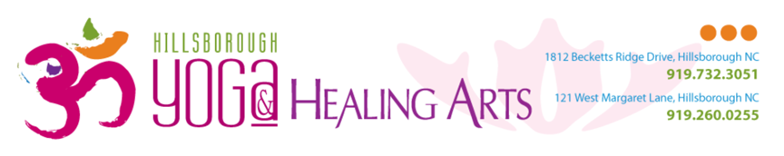
Private Yoga Lessons with Emily Burrows

I want you to have the most rewarding, personalized yoga lesson possible, and learning about your unique needs and interests is absolutely key. Please fill out the following form and send it to emilywellnesscoach@gmail.com at least 3 days in advance (Sunday night) of your first private yoga lesson. I’m looking forward to practicing with you!

Logistics
1) Name

2) Phone (in case we have trouble connecting)

3) Emergency Contact

Yoga
Our lessons can address anything ranging from adapting individual poses for an injury to designing an at-home yoga practice that you love. Don’t hesitate to tell me exactly what you hope to gain from our work together.

1) What would you like to accomplish with your yoga lessons?

2) Please describe your experience with yoga thus far:

3) What are your concerns with starting (or deepening) your yoga practice?

4) What are you hoping to learn during your private lesson?
Poses (asana) Meditation Breath (pranayama)
Creating an at-home yoga practice Other

Safety
Yoga is designed to be an individual practice, inspired by what your unique body, mind, and spirit need. Please include any health, mobility, or other conditions that could affect your comfort and safety.

1) Are you currently physically active?
2) If no, have you asked your doctor if it’s safe to start?

3) Which of the following apply to you?
Anxiety Asthma Back pain or injury
Chronic pain Depression Eating disorder
Fibromyalgia Fatigue Grief
Heart condition High blood press. Insomnia
Joint pain or injury Osteoporosis PTSD
Pregnancy Sacroiliac issue Other
Other Other Other
Comments

4) Is there anything else you’d like me to know before we start our work together?

Please send this completed form to EmilyWellnessCoach@gmail.com at least 3 days before your first private yoga lesson.

See you on the mat!

